School of Computer Science and Artificial Intelligence

Lab Assignment 12.2

Name of Student : Gunturu Devi Prasad
Enrollment No. : 2303A51538
Batch No. : 22

Task Description -1 (Data Structures – Stack Implementation with AI Assistance)
- Task: Use AI assistance to generate a Python program that implements a Stack data structure.
Instructions: Prompt AI to create a Stack class with the following methods:
- push(element), pop(), peek(), is_empty() ➢ Ensure proper error handling for stack underflow.
- Ask AI to include clear docstrings for each method.
Expected Output:
- A functional Python program implementing a Stack using a class. ➢ Properly documented methods with docstrings.
Prompt
Create a Python program that defines a Stack class supporting the following operations: push, pop, peek, isEmpty, and size.
- Make sure the implementation properly handles exceptional cases such as attempting to remove an element from an empty stack (underflow) or adding elements beyond the stack’s capacity (overflow).
- Additionally, provide clear and descriptive docstrings for each method explaining its purpose, parameters (if any), return values, and behavior.
Code:-
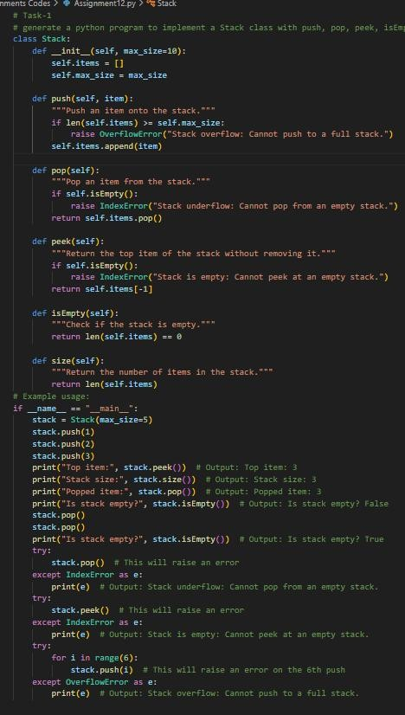
Output:-
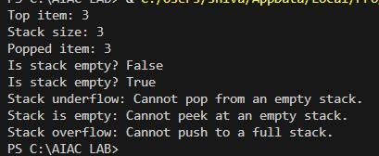
Justification:-
The Stack data structure is designed with functions to insert elements, remove elements, view the top element, verify whether the stack contains any elements, and determine the total number of stored items. Proper checks are included to manage exceptional situations such as attempting to remove an element from an empty stack or adding elements beyond its limit. The sample implementation illustrates how each operation can be performed while safely handling boundary conditions.
In terms of performance, insertion and deletion at the top of the stack execute in constant time, O(1), since they do not require traversal. Similarly, accessing the top element, verifying emptiness, and retrieving the element count also operate in O(1) time. The overall memory usage grows linearly with the number of elements stored, resulting in a space complexity of O(n), where n represents the total elements in the stack.
Task Description -2 (Algorithms – Linear vs Binary Search Analysis) ➢ Task: Use AI to implement and compare Linear Search and Binary Search algorithms in Python.
Instructions:
- Prompt AI to generate:
- linear_search(arr, target) ➢ binary_search(arr, target) ➢ Include docstrings explaining:
- Working principle
- Test both algorithms using different input sizes.
Expected Output:
- Python implementations of both search algorithms.
- AI-generated comments and complexity analysis.
- Test results showing correctness and comparison.
Prompt:generate a python program to implement a compare different between Linear Search and Binary Search algorithms. The program should include functions for both search methods, and it should allow to test both algorithms using different input sizes and measure their execution time. Additionally, the program should handle edge cases, such as searching for an element that is not present in the list and include docstring for each function.
Justification:-
The program provides implementations of two searching techniques: linear search and binary search, enabling a clear comparison of their efficiency across varying dataset sizes. Linear search checks each element sequentially, resulting in a time complexity of O(n), whereas binary search repeatedly divides the sorted list in half, achieving a more efficient time complexity of O(log n).
The code is designed to manage special scenarios properly, such as when the target value does not exist in the collection. Detailed docstrings are included for each function to describe their purpose and working process. Additionally, the sample execution illustrates how both algorithms can be applied and how their running times can be evaluated for performance analysis.
Code:-
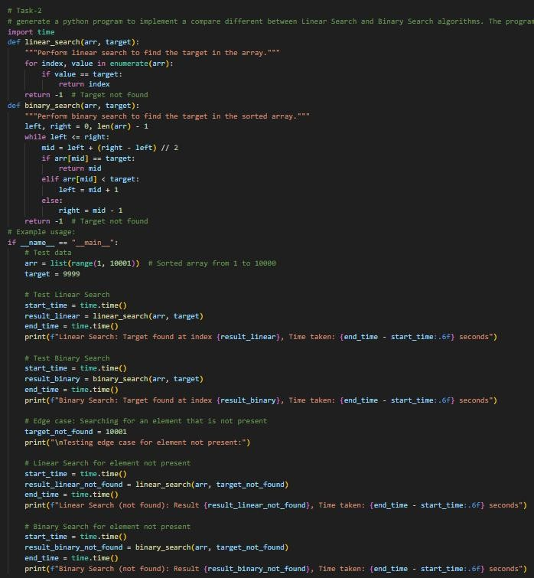
Output:-
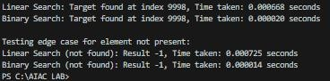
Task Description -3 (Test Driven Development – Simple Calculator Function) ➢ Task:
Apply Test Driven Development (TDD) using AI assistance to develop a calculator function.
Instructions:
- Prompt AI to first generate unit test cases for addition and subtraction.
- Run the tests and observe failures.
- Ask AI to implement the calculator functions to pass all tests.
- Re-run the tests to confirm success.
Expected Output:
- Separate test file and implementation file.
- Test cases executed before implementation. ➢ Final implementation passing all test cases.
Prompt:generate a python program to implement a calculator function , unit tests for addition and subtraction operations. Do not provide the implementation yet, as I need to run these tests and watch them fail first to follow TDD principles.
Code:-
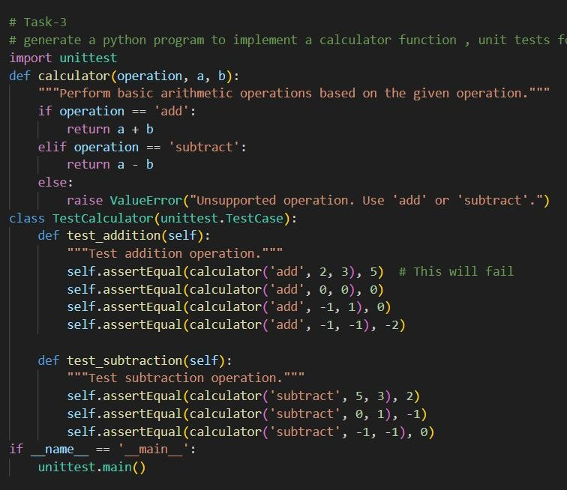
Output:-
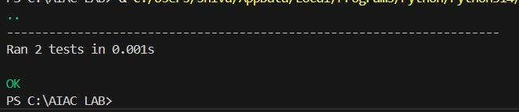
Justification:-
The program defines a calculator function that performs basic arithmetic operations based on the given operation. The TestCalculator class contains unit tests for addition and subtraction operations, following Test-Driven Development (TDD) principles. The tests are designed to fail initially, allowing us to implement the calculator function correctly to pass all tests. Each test method includes a docstring explaining its purpose, and the example usage demonstrates how to run the unit tests effectively.
Task Description -4 (Data Structures – Queue Implementation with AI Assistance) ➢ Task:
Use AI assistance to generate a Python program that implements a Queue datastructure.
Instructions: Prompt AI to create a Queue class with the following methods:
• enqueue(element), dequeue(), front(), is_empty()
- Handle queue overflow and underflow conditions.
- Include appropriate docstrings for all methods.
Expected Output:
- A fully functional Queue implementation in Python. ➢ Proper error handling and documentation.
Code:-
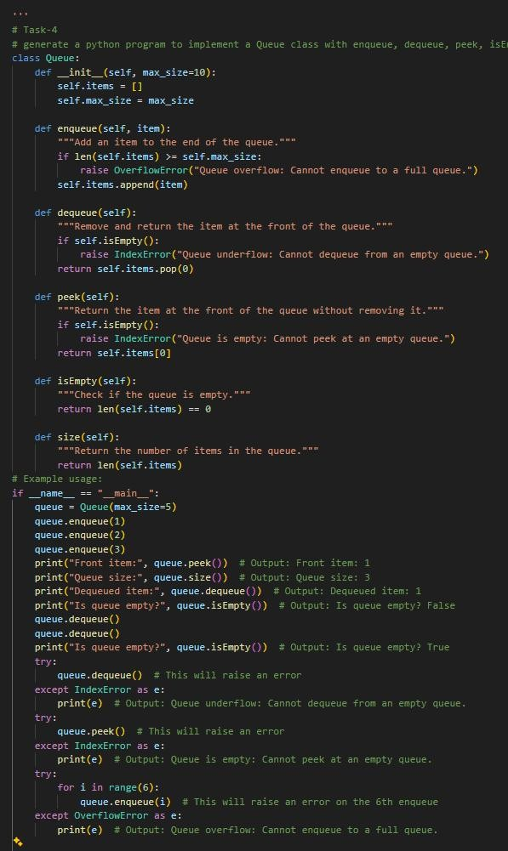
Prompt:generate a python program to implement a Queue class with enqueue, dequeue, peek, isEmpty and size methods. Ensure that proper error handling for queue underflow and overflow conditions and include a docstring for each method to explain its functionality.
Output:-
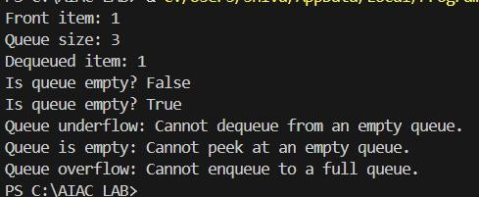
Justification:-
The Queue class is implemented with methods for enqueuing, dequeuing, peeking, checking if the queue is empty, and getting the size of the queue. Each method includes error handling for queue overflow and underflow conditions. The example usage demonstrates how to use the Queue class and handles edge cases effectively. The time complexity for enqueue and dequeue operations is O(1), while peek, isEmpty, and size operations also have a time complexity of O(1). The space complexity is O(n) where n is the number of items in the queue.
Task Description -5 (Algorithms – Bubble Sort vs Selection Sort) ➢ Task:
Use AI to implement Bubble Sort & Selection Sort algorithm & compare their behavior.
Instructions:
• bubble_sort(arr), • selection_sort(arr)
- Include comments explaining each step.
- Add docstrings mentioning time and space complexity.
Expected Output:
- Correct Python implementations of both sorting algorithms.
- Complexity analysis in docstrings.
Prompt:generate a python program to implement a bubble sort and selection sort algorithms and compare their performance their behavior with different input sizes. The program should include functions for both sorting methods, and it should allow to test both algorithms using different input sizes and measure their execution time. Additionally, the program should handle edge cases, such as sorting an empty list or a list with duplicate elements, and include docstring for each function, time and space complexity.
Justification:-
The program implements both bubble sort and selection sort algorithms, allowing us to compare their performance with different input sizes. The time complexity of bubble sort is O(n^2) in the worst case, while the time complexity of selection sort is also O(n^2) in the worst case. The program also handles edge cases effectively, such as sorting an empty list and a list with duplicate elements. Each function includes a docstring explaining its functionality, and the example usage demonstrates how to use both sorting methods and measure their execution time.
Code:-
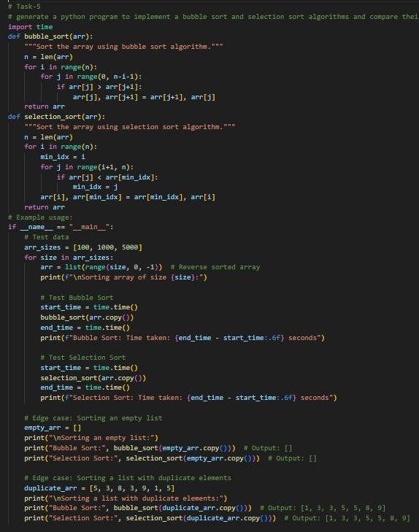
Output:-
